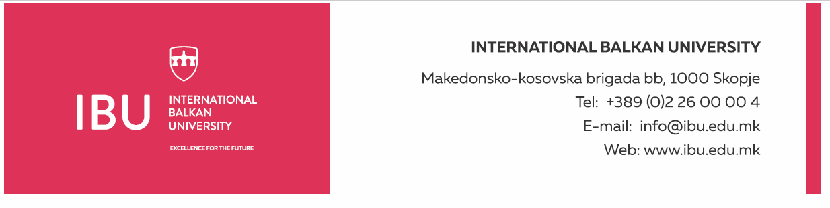

Based on Article 160, Paragraph (3) of the Higher Education Act ("Official Gazette of the Republic of North Macedonia", No. 82/18, 154/2019, and 178/2021), and in relation to Article 22, Paragraph (1), Item 1, Article 23, Article 24, Article 25, Article 26, and Article 27 of the Labor Relations Act ("Official Gazette of the Republic of North Macedonia", No. 62/05, 106/08, 161/08, 114/09, 130/09, 50/10, 52/10, 124/10, 47/11, 11/12, 39/12, 13/13, 25/13, 170/13, 187/13, 113/14, 20/15, 33/15, 72/15, 129/15, 27/16, 120/18, and "Official Gazette of the Republic of North Macedonia" No. 110/19), and the Rectorate's decision to announce a public call dated August 19, 2024, the International Balkan University in Skopje announces on August 19, 2024:

**PUBLIC CALL**

for establishing an employment relationship for 1 (one) person

The International Balkan University in Skopje is seeking to hire 1 (one) person for the following position:

**Accountant for Dental Clinic**

**General Conditions:**

* Short Biography (CV)
* Diploma in Accounting, Finance, Economics, or related fields
* Passed professional accounting exam or license will be considered an advantage
* Previous experience in accounting for healthcare institutions or similar entities (at least two years) will be considered an advantage
* Ability to communicate in English

**Specific Conditions:**

* Previous work experience in a similar position will be considered an advantage
* Experienced in maintaining financial records, preparing financial reports, and analyzing financial data
* Knowledge of accounting software and financial systems
* Excellent organizational skills and attention to detail

**Work Schedule:**

* Working days: Monday-Friday
* Working hours: 40 hours per week
* Working time: from 8:30 AM to 4:30 PM

**Applicants must submit the following documents:**

* Motivation letter
* Complete biography (CV)
* Educational diplomas (copy)
* Foreign diplomas must be nostrified and supplemented with an equivalency of grades

Documents should be submitted electronically to the following email address: hr@ibu.edu.mk

Documents should be submitted no later than August 30, 2024.

Only shortlisted candidates, upon request from the International Balkan University, will be required to submit a printed version of the above documents. Incomplete applications will not be considered.

**International Balkan University** Macedonian-Kosovar Brigade bb, 1000 Skopje

**INTERNATIONAL BALKAN UNIVERSITY Macedonian**-Kosovar Brigade bb, 1000 Skopje Tel: +389 2 55 15 000 Email: hr@ibu.edu.mk Website: www.ibu.edu.mk