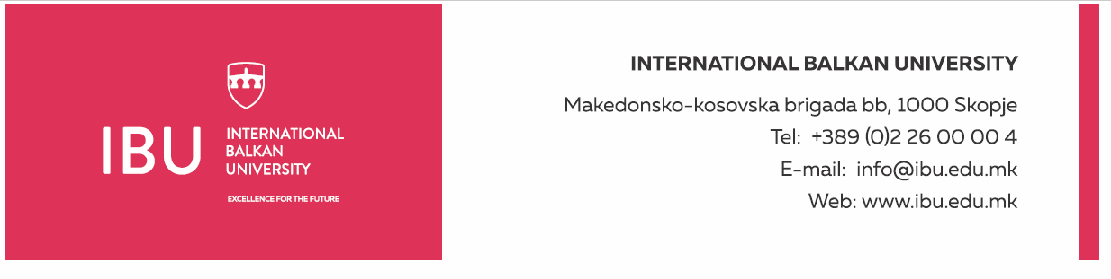

Based on Article 160, Paragraph (3) of the Higher Education Act ("Official Gazette of the Republic of North Macedonia", No. 82/18, 154/2019, and 178/2021), and in connection with Article 22, Paragraph (1), Item 1, Article 23, Article 24, Article 25, Article 26, and Article 27 of the Labor Relations Act ("Official Gazette of the Republic of North Macedonia", No. 62/05, 106/08, 161/08, 114/09, 130/09, 50/10, 52/10, 124/10, 47/11, 11/12, 39/12, 13/13, 25/13, 170/13, 187/13, 113/14, 20/15, 33/15, 72/15, 129/15, 27/16, 120/18, and "Official Gazette of the Republic of North Macedonia" No. 110/19), and the decision of the Rectorate to announce a public call dated August 19, 2024, the International Balkan University in Skopje announces on August 19, 2024:

**PUBLIC CALL**

for establishing an employment relationship for 1 (one) person

The International Balkan University in Skopje has a need to employ 1 (one) person for the following position:

**Administrative Assistant**

**General Conditions:**

* Short Biography (CV)
* Secondary or higher education in the field of administration, management, or similar areas
* Previous experience in an administrative assistant position or a similar role (at least one year) will be considered an advantage
* Ability to communicate in English
* Excellent knowledge of office software (MS Office, Google Workspace, etc.)

**Specific Conditions:**

* Excellent organizational and communication skills
* Ability to manage multiple tasks simultaneously and work under pressure
* Precision and attention to detail
* Ability to handle documents and maintain records

**Work Schedule:**

* Working days: Monday-Friday
* Working hours: 40 hours per week
* Working time: from 8:30 AM to 4:30 PM

**Applicants must submit the following documents:**

* Motivation letter
* Complete biography (CV)
* Diploma for completed education (copy)

Documents should be submitted electronically to the following email address: hr@ibu.edu.mk

Documents should be submitted no later than August 30, 2024.

Only shortlisted candidates, upon request from the International Balkan University, will be required to submit a printed version of the above documents. Incomplete applications will not be considered.

**International Balkan University** Macedonian-Kosovar Brigade bb, 1000 Skopje

INTERNATIONAL BALKAN UNIVERSITY Macedonian-Kosovar Brigade bb, 1000 Skopje

Tel: +389 2 55 15 000 Email: hr@ibu.edu.mk Website: www.ibu.edu.mk