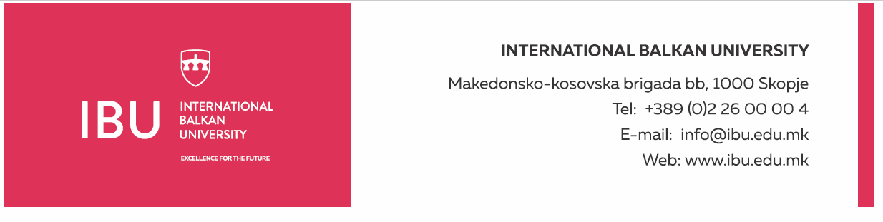

Based on Article 160, Paragraph (3) of the Higher Education Act ("Official Gazette of the Republic of North Macedonia", No. 82/18, 154/2019, and 178/2021), and in relation to Article 22, Paragraph (1), Item 1, Article 23, Article 24, Article 25, Article 26, and Article 27 of the Labor Relations Act ("Official Gazette of the Republic of North Macedonia", No. 62/05, 106/08, 161/08, 114/09, 130/09, 50/10, 52/10, 124/10, 47/11, 11/12, 39/12, 13/13, 25/13, 170/13, 187/13, 113/14, 20/15, 33/15, 72/15, 129/15, 27/16, 120/18, and "Official Gazette of the Republic of North Macedonia" No. 110/19), and the Rectorate's decision to announce a public call dated August 19, 2024, the International Balkan University in Skopje announces on August 19, 2024:

**PUBLIC CALL**

for establishing an employment relationship for 1 (one) person

The International Balkan University in Skopje is seeking to hire 1 (one) person for the following position:

**Alumni Center Officer**

**General Conditions:**

* Short Biography (CV)
* Completed higher education in social sciences, management, communications, or related fields
* Previous experience working with graduates or managing alumni relations (at least two years) will be considered an advantage
* Ability to communicate in English

**Specific Conditions:**

* Previous experience in a similar position will be considered an advantage
* Excellent communication and organizational skills
* Experienced in developing and maintaining alumni programs and initiatives, as well as managing alumni data
* Ability to build and maintain relationships with alumni and organize networking events and activities

**Work Schedule:**

* Working days: Monday-Friday
* Working hours: 40 hours per week
* Working time: from 8:30 AM to 4:30 PM

**Applicants must submit the following documents:**

* Motivation letter
* Complete biography (CV)
* Education certificate (copy)

Documents should be submitted electronically to the following email address: hr@ibu.edu.mk

Documents should be submitted no later than August 30, 2024.

Only shortlisted candidates, upon request from the International Balkan University, will be required to submit a printed version of the above documents. Incomplete applications will not be considered.

**International Balkan University** Macedonian-Kosovar Brigade bb, 1000 Skopje INTERNATIONAL BALKAN UNIVERSITY Macedonian-Kosovar Brigade bb, 1000 Skopje Tel: +389 2 55 15 000 Email: hr@ibu.edu.mk Website: www.ibu.edu.mk

Top of Form

Bottom of Form