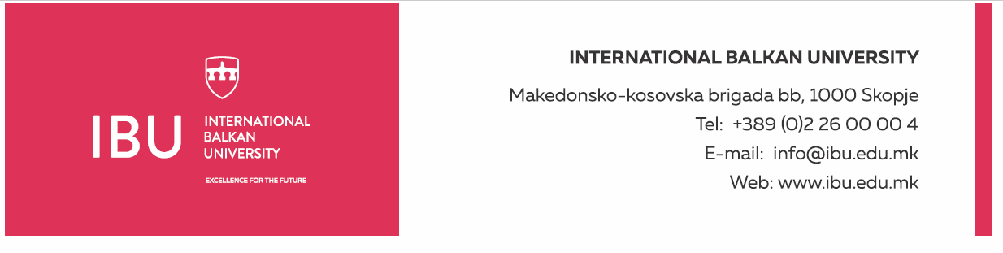

Based on Article 160, Paragraph (3) of the Higher Education Act ("Official Gazette of the Republic of North Macedonia", No. 82/18, 154/2019, and 178/2021), and in relation to Article 22, Paragraph (1), Item 1, Article 23, Article 24, Article 25, Article 26, and Article 27 of the Labor Relations Act ("Official Gazette of the Republic of North Macedonia", No. 62/05, 106/08, 161/08, 114/09, 130/09, 50/10, 52/10, 124/10, 47/11, 11/12, 39/12, 13/13, 25/13, 170/13, 187/13, 113/14, 20/15, 33/15, 72/15, 129/15, 27/16, 120/18, and "Official Gazette of the Republic of North Macedonia" No. 110/19), and the Rectorate's decision to announce a public call dated August 19, 2024, the International Balkan University in Skopje announces on August 19, 2024:

**PUBLIC CALL**

for establishing an employment relationship for 1 (one) person

The International Balkan University in Skopje is seeking to hire 1 (one) person for the following position:

**Dental Clinic Manager**

**General Conditions:**

* Short Biography (CV)
* Diploma in Health Sciences, Management, Administration, or related fields
* Candidates with a postgraduate or master’s degree will be given preference
* Previous experience in managing a dental clinic or similar healthcare institution (at least three years) will be considered an advantage
* Ability to communicate in English

**Specific Conditions:**

* Previous work experience in a similar position will be considered an advantage
* Good communication, organizational, and leadership skills
* Experienced in team management, strategic and operational planning, and strategy development
* Knowledge of regulations for managing healthcare institutions and dental practice

**Work Schedule:**

* Working days: Monday-Friday
* Working hours: 40 hours per week
* Working time: from 8:30 AM to 4:30 PM

**Applicants must submit the following documents:**

* Motivation letter
* Complete biography (CV)
* Educational diplomas (copy)
* Foreign diplomas must be nostrified and supplemented with an equivalency of grades

Documents should be submitted electronically to the following email address: hr@ibu.edu.mk

Documents should be submitted no later than August 30, 2024.

Only shortlisted candidates, upon request from the International Balkan University, will be required to submit a printed version of the above documents. Incomplete applications will not be considered.

**International Balkan University** Macedonian-Kosovar Brigade bb, 1000 Skopje

**INTERNATIONAL BALKAN UNIVERSITY** Macedonian-Kosovar Brigade bb, 1000 Skopje Tel: +389 2 55 15 000 Email: hr@ibu.edu.mk Website: www.ibu.edu.mk