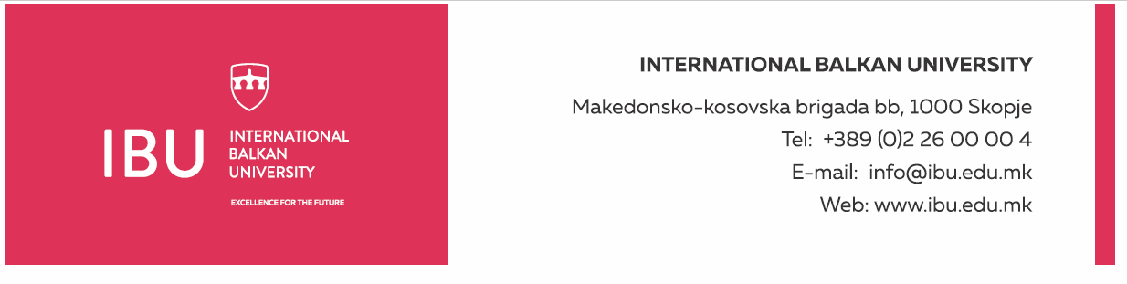

Based on Article 160, Paragraph (3) of the Higher Education Act ("Official Gazette of the Republic of North Macedonia", No. 82/18, 154/2019, and 178/2021), and in connection with Article 22, Paragraph (1), Item 1, Article 23, Article 24, Article 25, Article 26, and Article 27 of the Labor Relations Act ("Official Gazette of the Republic of North Macedonia", No. 62/05, 106/08, 161/08, 114/09, 130/09, 50/10, 52/10, 124/10, 47/11, 11/12, 39/12, 13/13, 25/13, 170/13, 187/13, 113/14, 20/15, 33/15, 72/15, 129/15, 27/16, 120/18, and "Official Gazette of the Republic of North Macedonia" No. 110/19), and the decision of the Rectorate to announce a public call dated August 19, 2024, the International Balkan University in Skopje announces on August 19, 2024:

**PUBLIC CALL**

for establishing an employment relationship for 1 (one) person

The International Balkan University in Skopje has a need to employ 1 (one) person for the following position:

**Graphic Designer for Media Center**

**General Conditions:**

* Short Biography (CV)
* Degree in graphic design, visual arts, or similar fields
* Knowledge of graphic design software such as Adobe Creative Suite (Photoshop, Illustrator, InDesign, etc.)
* Previous experience in graphic design (at least two years) will be considered an advantage
* Ability to communicate in English

**Specific Conditions:**

* A portfolio with examples of previous projects will be considered an advantage
* Good creative and visual skills
* Ability to work with deadlines and manage multiple projects simultaneously
* Experienced in developing visual concepts, branding, and designing promotional materials

**Work Schedule:**

* Working days: Monday-Friday
* Working hours: 40 hours per week
* Working time: from 8:30 AM to 4:30 PM

**Applicants must submit the following documents:**

* Motivation letter
* Complete biography (CV)
* Diploma for completed education (copy)
* Portfolio with examples of previous projects (in electronic form)

Documents should be submitted electronically to the following email address: hr@ibu.edu.mk

Documents should be submitted no later than August 30, 2024.

Only shortlisted candidates, upon request from the International Balkan University, will be required to submit a printed version of the above documents. Incomplete applications will not be considered.

**International Balkan University** Macedonian-Kosovar Brigade bb, 1000 Skopje INTERNATIONAL BALKAN UNIVERSITY Macedonian-Kosovar Brigade bb, 1000 Skopje Tel: +389 2 55 15 000 Email: hr@ibu.edu.mk Website: www.ibu.edu.mk