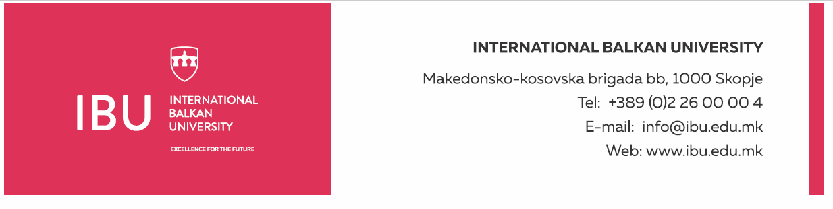

Based on Article 160, Paragraph (3) of the Higher Education Act ("Official Gazette of the Republic of North Macedonia", No. 82/18, 154/2019, and 178/2021), and in connection with Article 22, Paragraph (1), Item 1, Article 23, Article 24, Article 25, Article 26, and Article 27 of the Labor Relations Act ("Official Gazette of the Republic of North Macedonia", No. 62/05, 106/08, 161/08, 114/09, 130/09, 50/10, 52/10, 124/10, 47/11, 11/12, 39/12, 13/13, 25/13, 170/13, 187/13, 113/14, 20/15, 33/15, 72/15, 129/15, 27/16, 120/18, and "Official Gazette of the Republic of North Macedonia" No. 110/19), and the decision of the Rectorate to announce a public call dated August 19, 2024, the International Balkan University in Skopje announces on August 19, 2024:

**PUBLIC CALL**

for establishing an employment relationship for 6 (six) persons

The International Balkan University in Skopje has a need to employ 6 (six) persons for the following positions:

**Nurses for the Dental Clinic**

**General Conditions:**

* Short Biography (CV)
* Degree in medical sciences, with a specific emphasis on dental care
* Passed professional exam for a nurse
* Previous experience working in a dental clinic or similar healthcare institution will be considered an advantage
* Ability to communicate in English

**Specific Conditions:**

* Previous work experience in a similar position will be considered an advantage
* Good communication and organizational skills
* Skills in patient care and ability to work in a team
* Knowledge of dental care protocols and laboratory procedures

**Work Schedule:**

* Working days: Monday-Friday
* Working hours: 40 hours per week
* Working time: from 8:30 AM to 4:30 PM

**Applicants must submit the following documents:**

* Motivation letter
* Complete biography (CV)
* Degree certificate (copy)
* Foreign diplomas must be nostrified and supplemented with grade equivalency

Documents should be submitted electronically to the following email address: hr@ibu.edu.mk

Documents should be submitted no later than August 30, 2024.

Only shortlisted candidates, upon request from the International Balkan University, will be required to submit a printed version of the above documents. Incomplete applications will not be considered.

**International Balkan University** Macedonian-Kosovar Brigade bb, 1000 Skopje INTERNATIONAL BALKAN UNIVERSITY Macedonian-Kosovar Brigade bb, 1000 Skopje Tel: +389 2 55 15 000 Email: hr@ibu.edu.mk Website: www.ibu.edu.mk